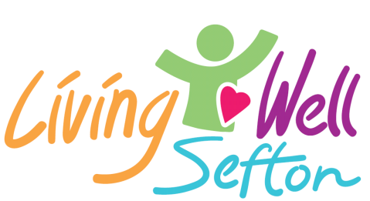

Workplace Wellbeing Grants 2022/23
Looking after the wellbeing of your employees will make you a stronger organisation with a happier, healthier workforce, especially as people return to work after the lifting of lockdown measures. It also shows that you care about the people who work for you. Improving workplace wellbeing can also contribute to reduced absenteeism, increased productivity, and support staff to improve their lifestyles.
Living Well Sefton, in partnership with Sefton Public Health, is offering ‘Small to Medium Enterprises’ (SMEs) grants of up to £500 to improve the wellbeing of employees.

What we will consider funding
- Staff costs including sessional staff, for example for workplace wellbeing activities such as yoga or mindfulness
- Volunteer costs and costs associated with allowing staff to volunteer during work time
- Equipment, for example bike racks to encourage active travel to work
- Training courses which are focused on wellbeing
- Events to support the wellbeing of staff
- Refurbishment of facilities which are clearly demonstrated to contribute to the health and wellbeing of staff, for example decorating a break room or buying a table and chairs to encourage people to each lunch away from their desks.

What we will not fund
- Core or ongoing running costs
- Overhead allocations
- Statutory responsibilities
- Overseas travel expenses
- Personal debts
- Grants to individuals
- Legal costs
- Redundancy payments
- Sole traders
- Schools

Eligibility
- Primary business activities must be in Sefton
- More than 60% of employees must be Sefton residents
- Priority will be given to businesses who employ routine and manual workers
- The applying organisation must not have been funded for a workplace wellbeing grant in the last 12 months for the same activity
- Any funding awarded must be spent within 6 months of receiving the payment via the bank account on the application form
- The applying organisation must have a minimum of five employees that will benefit from the grant

SECTION 1 – Organisation
Organisation Name and Address:
Contact person:

Role in the Organisation:

Telephone:

Email:

Are you a small to medium sized enterprise? i.e. less than 250 employees | Yes | No
Are at least 60% of your employees Sefton residents | Yes | No
Are you a registered Charity? | Yes  Charity Number: | No
Are you a Company Limited by Guarantee? | Yes  Company Number: | No
Are you a Community Interest Company? | Yes  Company Number: | No
Bank Details: | Sort Code:  Account Number:  Account Name:

SECTION 2 – Your Project
Please answer each question below to help us to understand the project that you are requesting funding for.
What are you aiming to do and why?
How will the activity improve the wellbeing of your staff?
What will the lasting benefits be?
When would you expect the project to start and finish?
Please provide an itemised breakdown of the project requirements and their likely cost.  Please tell us how much the TOTAL project will cost and how much funding are you asking for from the Workplace Wellbeing Grant. | Item | Cost
 | Total cost of project | £
 | Funding requested from Living Well Sefton | £
If the total cost is more than you are requesting, where are you getting the rest from?

Declaration:

I declare that to the best of my knowledge and belief the information supplied on this application form is correct. This application is in compliance with the guidance notes and I confirm that I have the authority to sign on behalf of the organisation making this application. | Signed:
 | Position:
 | Date:

You can return your form: Please complete and return this form via email to workplacegrants@seftoncvs.org.uk or by post to Living Well Sefton, Sefton CVS, Burlington House, Crosby Road North, Waterloo, L22 0LG.

