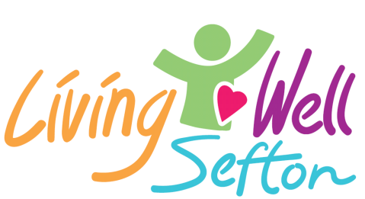

Round 7 - COMMUNITY RESILIENCE GRANT APPLICATION FORM
2020
Small grant funding of up to £2,000 for local community health & wellbeing projects aiming to encourage outdoor activities.

SECTION 1 – Lead Organisation
Organisation Name and Address:
Contact person:
Role in the Organisation:
Telephone:
Email:
Do you have a constitution? | Yes | No
Are you a registered Charity? | Yes  Charity Number: | No
Are you a Company Limited by Guarantee? | Yes  Company Number: | No
Are you a Community Interest Company? | Yes  Company Number: | No
Are you an Unincorporated Association? | Yes | No
Bank Details: | Sort Code:  Account Number:  Account Name:

SECTION 2 – Your Project
Please answer each question below to help us to understand the project that you are requesting funding for.
Project Name:
What are you aiming to do and why? (300 characters)

How will your project actively engage local people in making positive changes to their health and wellbeing in our communities?

What will the outcomes be of this project?

When would you expect the project to start and finish?
Who will mainly benefit from your project?  (Please tick at least one). | Young People  Older People  General Community  Resident Association  Sports or Arts  Minority groups (e.g. LGBT, Disabled, BAME)  Other:
Do you have the necessary insurance, risk assessments, Health and Safety procedures in place? | Public Liability Insurance  Employer’s Liability Insurance  Risk Assessments  Health and Safety procedure |  | Yes  Yes  Yes  Yes | No  No  No  No
If your project involves working with vulnerable adults or children, please confirm that you have a Safeguarding Policy and that the relevant staff / volunteers have a current DBS check.  Living Well Sefton can support individuals/ organisations with achieving this. | Safeguarding Policy  DBS checks |  | Yes  Yes | No  No
Please provide an itemised breakdown of the project requirements and their likely cost.  Please tell us how much the TOTAL project will cost and how much funding are you asking for from the Community Resilience Grant. | Item |  |  | Cost
 | Total cost of project |  |  | £
 | Funding requested from Community Grant |  |  | £
If the total cost is more than you are requesting, where are you getting the rest from?
Who will be running the activity? | Volunteers | How many?
 | Paid Staff | How many?

Declaration:

I declare that to the best of my knowledge and belief the information supplied on this application form is correct. This application is in compliance with the guidance notes and I confirm that I have the authority to sign on behalf of the organisation making this application. | Signed:
 | Position:
 | Date:

You can return your form: Please complete and return this form via email to LWS@seftoncvs.org.uk or by post to Living Well Sefton, FREEPOST RTCG-HGYH-LHRS,
Sefton CVS, 3rd Floor, Suite 3B, North Wing, Burlington House, Crosby Road North, Waterloo, L22 0LG.

