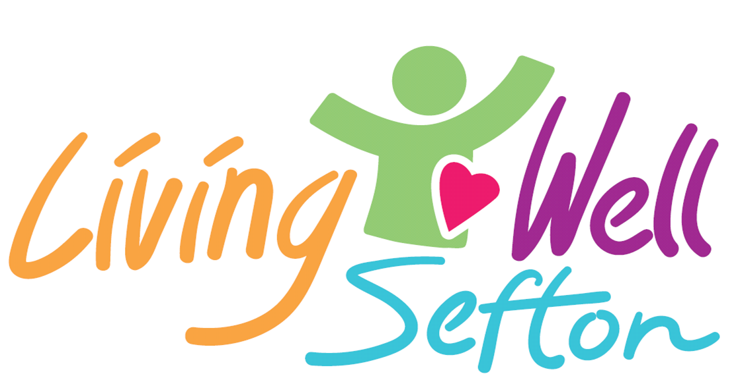

Application Guidance
Living Well Sefton Community resilience grant – online form
Thanks for expressing an interest in applying for our Living Well Sefton grant. This guidance explains what is expected on the online application form and will hopefully make the process a little easier for you. The main point to note is that the form needs to be completed in one go so having all of the info to hand will make things simpler!
Section 1
The first question on the form is to determine if you are applying for a grant as an individual (max £500) or on behalf of an organisation (max £2,500).
If you are applying as an individual we just need to know your name and contact details and which organisation you will be supported by. If you have an idea but aren’t currently in touch with an organisation, give us a call and we can discuss that with you.
If you are applying on behalf of an organisation we will need to know your role within the organisation and contact details. We also need to know standard information such as if you have public liability insurance, risk assessments in place, Charity or Company number etc.
Section 2
Section 2 gives you the chance to tell us about your project idea and how it will benefit the community. Both individuals and organisations are asked the same questions. We have a word limit on each section. The word limits give you enough space to tell us about the project without making the form to onerous to complete or read! We would like it simple and to the point.
We would like you to answer the following questions:
- What is the name of your project?
- What are you aiming to do and why? (300 characters)
- How will your project actively engage local people in making positive changes to their health and wellbeing in our communities? (900 characters)
- What will the outcomes of the project be? (900 characters)
- When do you expect the project to start and finish? (300 characters)
It may be useful to use Microsoft Word to check the number of characters in your answers, then cut and paste into the form.
We will also ask you to select from a list who will benefit from your project e.g. older people, families etc.
If you are working with vulnerable adults or children, we will ask if you have a safeguarding policy and appropriate DBS checks in place. If you are applying as an individual we will ask your partner organisation to support with this if your application is successful.
We will ask you to tell us how much money you are applying for and how you will spend the money. We want to get maximum impact for the grant fund so we want to see that you plan to spend the money well. This section allows you to detail the project costs and tell us how you intend to fund any shortfall in the overall cost. There is no word limit on this section but it should not be used to add information we have already asked you about. We will only consider financial information added to this question.
If you have any questions please let us know. You can get in touch by emailing LWS@seftoncvs.org.uk.
We look forward to receiving your applications!

